**Weather Impact on Honey Production in Alberta (2017–2021)**

**Overview and Objective**

To analyse various variables of the weather data from Alberta (2017-2021) and assess their impact on honey production. This includes monthly and yearly trends, and how environmental conditions during different bee life stages influence honey yields. The data includes the following key weather features (renamed for convenience):

* Air Temp. Avg. → AvgTemp
* Precip. → Precip
* Relative Humidity Avg. → Humidity
* Incoming Solar Rad. → SolarRad
* Wind Speed → WindSpeed

Additional engineered features include:

* Temperature deviation from the ideal bee foraging temperature (28°C) → Average_Diff_28
* Number of days within ±15°C of 28°C → Days_Within_15Deg

**Monthly Weather Trends**

|  |  |  |  |  |  |  |  |  |
| --- | --- | --- | --- | --- | --- | --- | --- | --- |
| Year | month | AvgTemp | Average_Diff_28 | Days_Within_15Deg | Total_Precip | Mean_Humidity | Mean_WindSpeed | Total_SolarRad |
| 2017 | 3 | -6.356935 | 34.356935 | 0.0 | 6.62 | 73.266129 | 12.676774 | 336.06 |
| 2017 | 4 | 2.867167 | 25.132833 | 0.0 | 36.26 | 72.360667 | 13.644333 | 424.32 |
| 2017 | 5 | 11.868710 | 16.131290 | 12.0 | 59.38 | 57.061935 | 14.594194 | 596.77 |
| 2017 | 6 | 14.987667 | 13.012333 | 22.0 | 46.05 | 59.528667 | 14.330667 | 630.61 |
| 2017 | 7 | 16.325161 | 11.674839 | 29.0 | 54.18 | 67.918065 | 11.716774 | 636.84 |
| 2017 | 8 | 15.925000 | 12.075000 | 30.0 | 64.14 | 68.473548 | 12.487419 | 530.86 |
| 2017 | 9 | 11.534167 | 16.465833 | 10.0 | 47.17 | 73.255333 | 11.956000 | 325.99 |
| 2018 | 3 | -7.980645 | 35.980645 | 0.0 | 23.25 | 76.597097 | 13.501290 | 347.38 |
| 2018 | 4 | -0.928667 | 28.928667 | 0.0 | 13.30 | 66.887000 | 14.469000 | 530.98 |
| 2018 | 5 | 13.785323 | 14.214677 | 20.0 | 13.18 | 46.902258 | 15.155806 | 699.01 |
| 2018 | 6 | 14.852333 | 13.147667 | 17.0 | 117.32 | 64.188667 | 14.132000 | 606.81 |
| 2018 | 7 | 16.145645 | 11.854355 | 25.0 | 142.23 | 73.228710 | 11.998710 | 651.19 |
| 2018 | 8 | 15.034516 | 12.965484 | 23.0 | 35.28 | 73.491290 | 11.678387 | 486.38 |
| 2018 | 9 | 4.910833 | 23.089167 | 1.0 | 27.55 | 76.814333 | 10.414333 | 288.99 |
| 2019 | 3 | -4.184516 | 32.184516 | 0.0 | 0.61 | 67.791290 | 11.085806 | 397.47 |
| 2019 | 4 | 3.326333 | 24.673667 | 0.0 | 16.00 | 57.821000 | 14.033333 | 474.91 |
| 2019 | 5 | 10.469194 | 17.530806 | 13.0 | 8.60 | 46.138710 | 14.122258 | 634.82 |
| 2019 | 6 | 13.937500 | 14.062500 | 21.0 | 77.65 | 66.166000 | 13.313000 | 600.28 |
| 2019 | 7 | 15.565161 | 12.434839 | 26.0 | 133.09 | 77.850645 | 10.134194 | 583.47 |
| 2019 | 8 | 13.511452 | 14.488548 | 17.0 | 56.63 | 79.016129 | 9.778387 | 468.25 |
| 2019 | 9 | 10.277500 | 17.722500 | 9.0 | 33.46 | 76.772667 | 12.062000 | 317.59 |
| 2020 | 3 | -9.694677 | 37.694677 | 0.0 | 21.47 | 72.817742 | 15.385484 | 361.53 |
| 2020 | 4 | 0.028000 | 27.972000 | 0.0 | 8.50 | 63.913333 | 13.997667 | 549.44 |
| 2020 | 5 | 9.718387 | 18.281613 | 6.0 | 50.86 | 63.024194 | 13.925484 | 590.67 |
| 2020 | 6 | 13.943000 | 14.057000 | 20.0 | 95.43 | 69.469667 | 13.108333 | 583.97 |
| 2020 | 7 | 16.227419 | 11.772581 | 31.0 | 87.17 | 76.589032 | 11.322581 | 598.61 |
| 2020 | 8 | 15.039839 | 12.960161 | 20.0 | 31.87 | 68.637419 | 13.601935 | 545.49 |
| 2020 | 9 | 10.822833 | 17.177167 | 9.0 | 15.58 | 69.684333 | 12.235333 | 340.17 |
| 2021 | 3 | -3.559194 | 31.559194 | 0.0 | 13.22 | 71.262581 | 14.385806 | 346.36 |
| 2021 | 4 | 2.128167 | 25.871833 | 0.0 | 18.03 | 61.902333 | 13.123000 | 530.67 |
| 2021 | 5 | 10.464194 | 17.535806 | 8.0 | 39.59 | 55.937097 | 13.759355 | 589.57 |
| 2021 | 6 | 17.056833 | 11.218167 | 23.0 | 36.27 | 56.447000 | 13.606667 | 710.36 |
| 2021 | 7 | 17.369839 | 10.630161 | 27.0 | 20.44 | 63.642581 | 11.599677 | 650.27 |
| 2021 | 8 | 15.526129 | 12.473871 | 21.0 | 49.74 | 67.917097 | 13.188387 | 467.51 |
| 2021 | 9 | 11.536000 | 16.464000 | 10.0 | 31.52 | 67.968667 | 13.691000 | 361.25 |

**Days Within 15°C of 28°C by Month**

visualizing the number of days each month (from March to September) had temperatures within ±15°C of the ideal 28°C — i.e., between 13°C and 43°C.

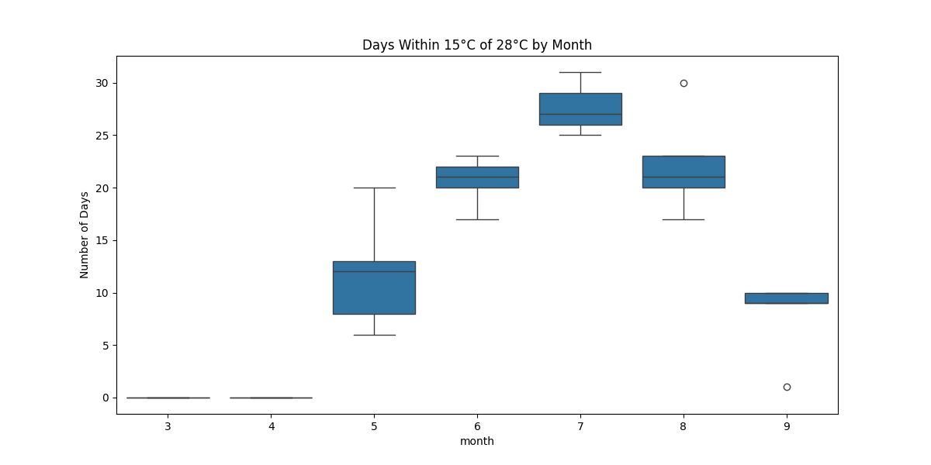

* June and July offer the best thermal environment for bees.
* Early spring and late summer/fall months are less favourable.
* This aligns with peak bee activity and brood development timing in warmer months

**Temperature**

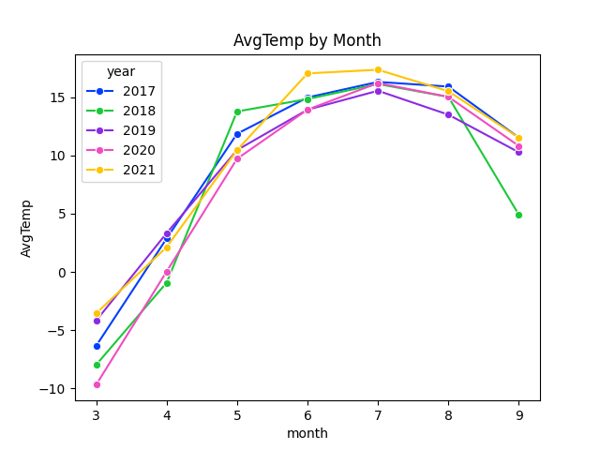

* Average temperatures increase steadily from March through July, peaking around 16–18°C, then decline through September.
* July consistently offers the highest number of “optimal days” (within ±15°C of 28°C), making it a critical period for bee activity.

**Precipitation**

* High variability observed across years.
* 2018 and 2019 recorded significant precipitation peaks during June and July.
* Excessive rainfall during peak months may hinder bee foraging and nectar availability.

**Humidity**

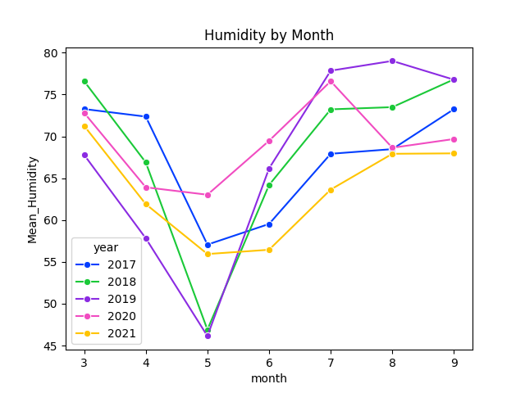

* Humidity drops sharply in May, then rises from June through August.
* 2020 experienced relatively lower humidity across months compared to other years.

**Wind Speed**

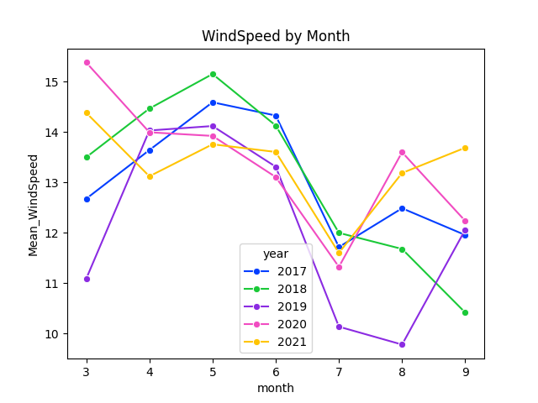

* Wind speeds are moderate but fluctuate across years.
* Higher wind speeds tend to occur in early months (April–May), decreasing mid-summer.

**Solar Radiation**

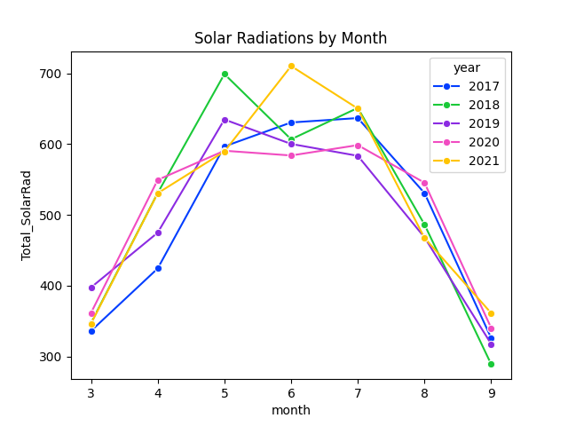

* Peaks around June across all years before tapering off.
* 2021 saw the highest solar radiation levels, especially in mid-year months.

**Correlation with Honey Production (Yearly Summary)**

**Annual Honey production:**

Key points:

* Production peaked in 2017 (~40.6M lbs).
* It declined steadily until 2020 (~30.7M lbs).
* A partial rebound occurred in 2021 (~34.9M lbs).

The chart highlights a downward trend overall, with a small recovery at the end

To assess direct influence, annual average or total values were correlated with total annual honey production.

**Observed Correlation Coefficients:**

* **AvgTemp**: 0.25
* **WindSpeed**: 0.25
* **Precip**: -0.18
* **SolarRad**: -0.005
* **Humidity**: -0.10

**Interpretation:**

While there is a mild positive correlation between honey production and both average temperature and wind speed, these relationships are relatively weak. Other variables, including precipitation and humidity, show negative or negligible correlations.

**Conclusion**:

Annual aggregation appears to dilute the effects of weather variables on bee development and honey output. Since bee development is highly sensitive to environmental conditions at specific life stages, a finer-grained analysis by life stage is warranted to uncover stronger patterns.

**Bee Stage-Specific Correlations (Detailed Analysis)**

To capture nuanced impacts, weather metrics were correlated with honey production across three bee life stages:

* **Larva** (March, April, October)
* **Pupa** (May, June)
* **Adult** (July, August, September)

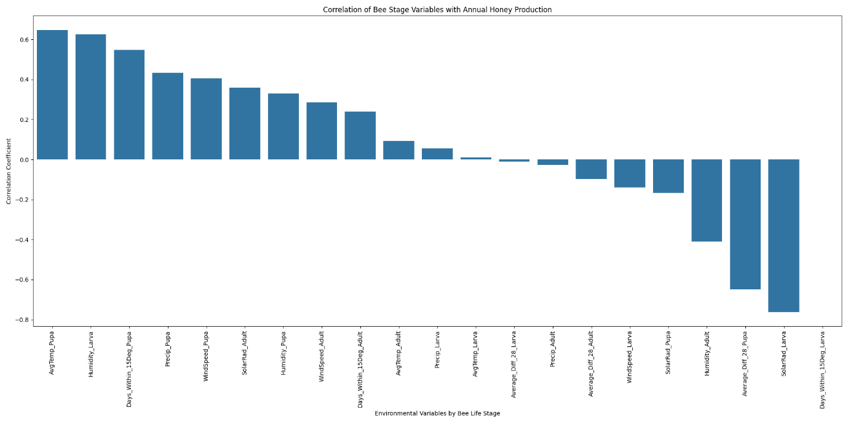

**Top Positive Correlations:**

* **AvgTemp_Pupa (0.65)**: Warmer temperatures during the pupal stage significantly enhance honey production. This likely reflects improved developmental success and transition into productive adults.
* **Humidity_Larva (0.63)**: Higher humidity levels during the larval stage are beneficial. Humid environments may reduce larval mortality and improve brood health.
* **DaysWithin15Deg_Pupa (0.54)**: Consistency in temperature near the optimal 28°C during the pupal phase boosts honey output, likely by supporting stable development.
* **Precip_Pupa (0.44)**: Moderate precipitation during pupal months may aid floral growth, indirectly enhancing nectar availability.
* **WindSpeed_Pupa (0.41)**: Moderate wind may aid in plant pollination and air circulation, reducing disease risk in hives.

**Top Negative Correlations:**

* **SolarRad_Larva (-0.76)**: High solar radiation during the larval stage is strongly detrimental. Overheating or dry conditions may lead to larval stress or mortality.
* **Average_Diff_28_Pupa (-0.67)**: Larger deviations from the optimal temperature during pupal development hurt honey production, emphasizing the importance of thermal stability.
* **Humidity_Adult (-0.48)** and **SolarRad_Pupa (-0.44)**: Excess humidity or intense solar radiation during these stages may disrupt foraging or hive activity.

**Key Takeaways**

**1. Pupal Stage is Most Critical**

* Temperature stability and moderate weather during May–June (pupal development) have the highest impact on honey production. This stage determines the strength of the future forager population.

**2. Early Stage (Larva) Sensitivity**

* High solar radiation and low humidity during the larval phase (March–April) can be harmful. These conditions should be mitigated if possible, e.g., by shading hives or maintaining moisture.

**3. Adult Stage Less Influential**

* Weather conditions during the adult stage (July–September) show weaker correlations, suggesting that colony success is largely determined earlier in the season.

**4. Annual Metrics are Inadequate**

* Correlations at the annual level are weak. Aggregating data by bee life stages reveals much stronger relationships, highlighting the importance of stage-specific environmental monitoring.

**5. Actionable Insight for Beekeepers**

* To maximize honey yield, prioritize optimal environmental conditions during the larval and pupal stages. Interventions could include:
  + Hive positioning to moderate solar exposure
  + Moisture management early in the season
  + Monitoring temperature stability in late spring